# Annex 1 Table of reference flows

#### Scenario 1 Virgin filament System:

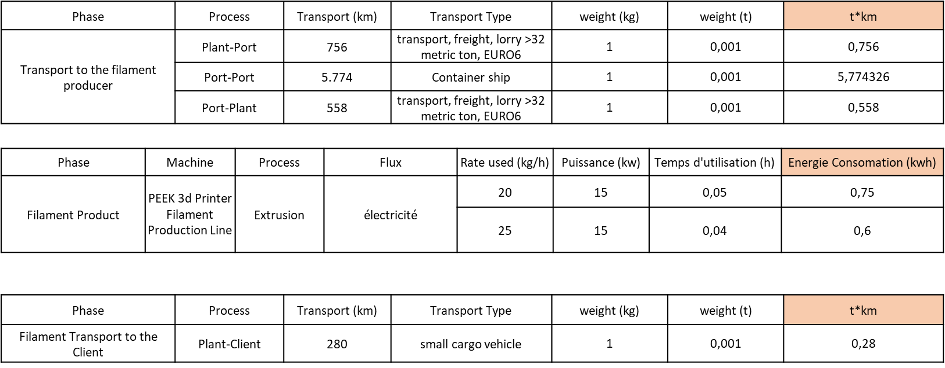

#### Scenario 2 Virgin filament System:

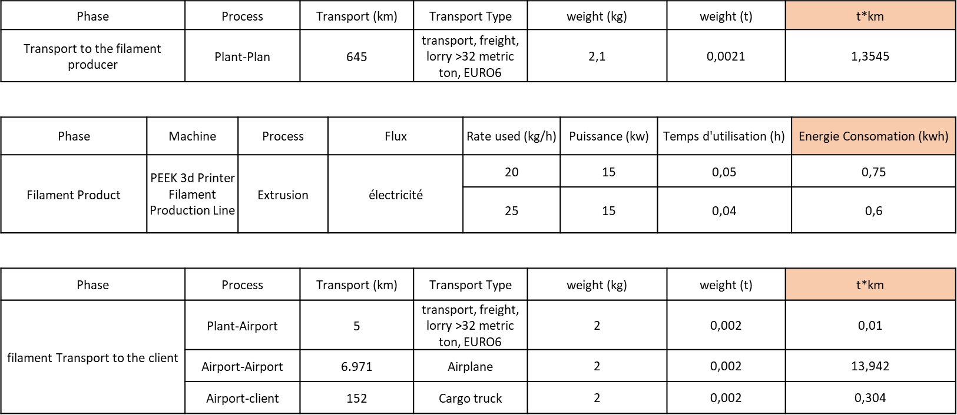

#### Scenario 3 Recycled filament system:

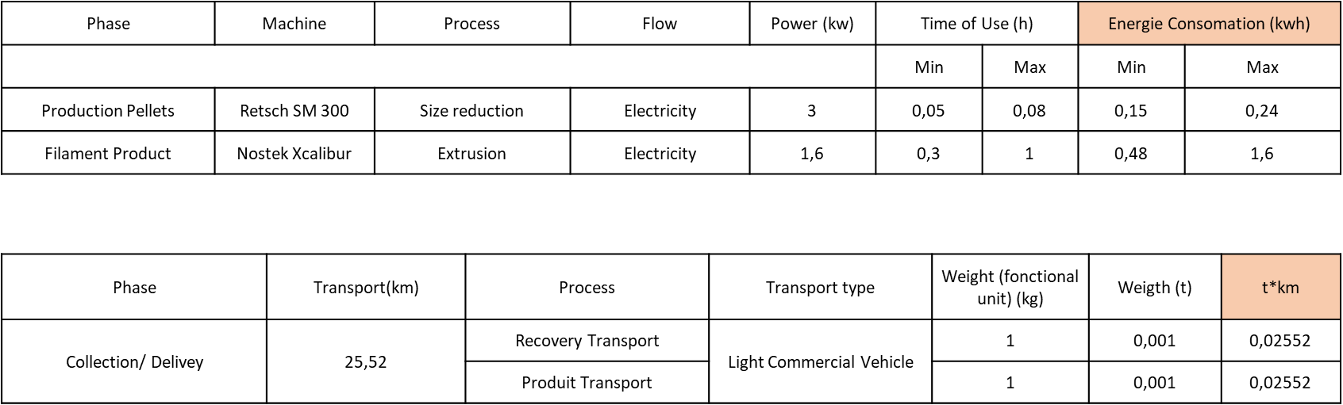

#### Transport route for the recycling scenarios:

